Exquisitely designed, this new range is guaranteed to enhance your swimming pool, patio, garden, boat, and any other outdoor area: whether you are in the residential, commercial, or hospitality sector.
Keeping you, your guests and your clients completely entertained.
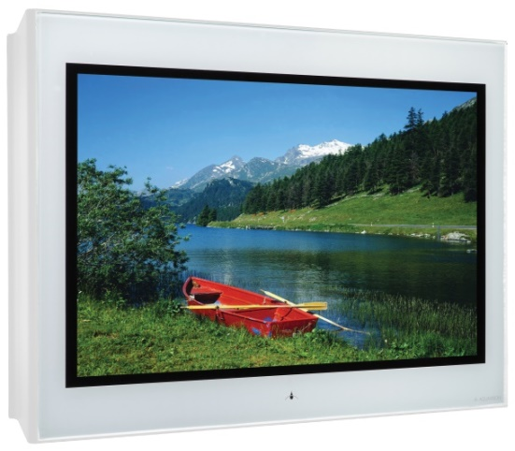
Based on our Pinnacle2 Smart range and packed with features such as 1080p and 2160p inputs, IP control, DVB-T2/S2 receivers, 2 HDMI and USB inputs, this Fully IP66 rated television provides the ultimate protection against water, dust, sand, moisture and insects.

All Aquavision televisions are widescreen (16:9) with a viewing angle of 178 x 178. Offering brightness levels of up to 2000cd/m², your
Aquavision outdoor television provides a high quality, high-brightness
LED Television. Supplied as standard with a wide range of inputs and
with IP control as standard, this product is fully compatible with all
leading control systems.

All Aquavision High Brightness Horizon screens come with the following features:
- Aquavision’s CTM (Comprehensive Thermal Management), constantly monitoring humidity and temperature, and adjusts where necessary.
- Aquavision’s ADST (Advanced Daylight Sensing Technology) constantly monitors and adjusts screen brightness to ambient light level to enhance your viewing experience and prolong the life of your Aquavision.
- These screens also incorporate heaters enabling them to be stored and to operate in extremely cold environments without any problems.
- Constantly monitored ad adjusted according to ambient light Antireflective/antiglare glass for enhanced viewing
- Optional accessory slot for Balan’s, DM receivers, HDBaseT receiver’s etc. enabling total integration with proprietary band operating systems whilst still retaining waterproof qualities.

Specification
Panel Size | 43” |  | 55’’ |  | 65’’ |  | 86” |  | 100”
Dims (mm) | 1062 x 675 x 135 |  | 1340 x 819 x 135 |  | 1594 x 974 x 135 |  | 2070 x 1243 x 135 |  | 2350 x 1388 x 135
Weight | 50kg |  | 65kg |  | 80kg |  | 150kg |  | 230kg
VESA Mounts | 800 x 400 or 600 x 400 |  | 800 x 600 |  | 800 x 600 |  | 800 x 600 1000 x 600 |  | 800 x 600 or 1000 x 600
Resolution | 4K |  | 4K |  | 4K |  | 4K |  | 4K
Operating Temp | High Brightness -40°F to 230°F (-40°C to 110°C)
Brightness | 2000 cd/m² | 2000 cd/m² |  | 2000 cd/m² |  | 2000 cd/m² |  | 2000 cd/m² |  | 1500 cd/m²

Features |  |  | Connectors
Full Remote Control |  | Yes | Amplified Audio Out |  |  | Yes
H264/265 |  | Yes | HDMI |  |  | 2
Anti-reflective glass |  | Yes | Tuner |  |  | DVB-C/T/T2/S/S2.Pal I,B/G,D/K
Tempered safety glass |  | Yes | Audio Out |  |  | SPDIF Coax
User Selectable Sound Control |  | Yes | USB2.0 |  |  | Yes
Tone Control |  | Yes | Control
Channel edit |  | Yes | IP Control |  |  | Yes
Audio Output |  | 2 x 8w RMS | CEC/ARC on HDMI |  |  | Yes
Power Supply |  | AC 100-240V. Connector supplied for you to connect to desired cable length
Picture
Comb Filter |  |  |  | 3D
De-interlace Scan/Progressive Scan |  |  |  | Yes
User Selectable Picture Control |  |  |  | Yes
Tint, colour, brightness, contrast, sharpness control |  |  |  | Yes
Android Smart Features
Processor | CPU | CA9*2core@1.0G | WLAN |  | Max Data Rate |  | 150Mbps/300Mbps
 | GPU | Mali400mp2 |  |  | Operating Frequency |  | 2.4GHz
 | O/S | Android 6.0 |  |  | Communications Standard |  | IEEE 802.11b/g/n
 | RAM | External 512M*2+Internal 512M | RJ45 NETWORK |  |  |  | 10/100M auto-ident & DHCP
 | eMMC Flash | 4GB/8GB

Connector Details
